Three step eye shadow application enabling beautiful eyes
Complete the eyes in the left hand column using the examples of the techniques

Highlighters Step One: Apply on brow bone and lid using the lightest eyeshadow or shimmer
 | 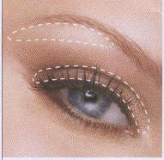
Midtones Step Two: Apply in crease starting at the outer corner of the eye using a medium tone colour which is atleast two shades deeper
 | 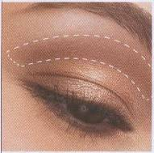
Accents Step Three: Apply and blend along top lashline and into outside half of crease Use a dark contrast eyeshadow to accentuate giving definition
 | 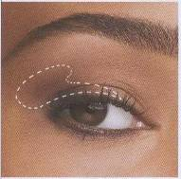

Activity
Combine the highlighter technique, midtone technique, accent technique.

Design your eye shadow to accentuate your models eyes, giving definition while highlighting your models best asset their eyes.

Record your makeup selection include your foundation base colour / powder/ mascara/ eyeliner/ cheek colour face paint /body paint/ you can dab the colours on this resource to keep track of your colour scheme.
Notes:
....................................................................
....................................................................
....................................................................
....................................................................
....................................................................
....................................................................
....................................................................
....................................................................
....................................................................
Picture reference: Mary Kay cosmetics and Microsoft clip art

