Hypothesis Testing of a Single Mean--Hrs per week watching tv
From activity: http://wikieducator.org/Hypothesis_testing_of_a_single_mean--hrs/wk_watching_tv

Scenario: The 1st quarter 2010 Nielsen survey concludes that Americans (2 years and older) watch television on average 35.57 hours per week. It seems likely that graduate students do not watch nearly this much television per week.
Sample: Stat Methods II student estimates of hrs per week spent watching tv
Data Analysis: Complete the following steps, making notes in response to directions as appropriate:
- State the appropriate null and alternative hypotheses and set the significance level.
Ho:
Ha:
Significance level:

  - In words, clearly state what your random variable, X-bar, represents.

  - State what test statistic, and whether one-tailed or two-tailed, will be used to summarize the data.

- Use the collected class data as your sample. Check whether the data meet the conditions under which the test can be used. If the conditions are met, summarize the data by a test statistic.
  - Calculate summary statistics and create a histogram (or stemplot) based on the sample data.
  - Confirm that the conditions for use of the chosen test statistic have been met. (Continue even if conditions not met, and be ready to discuss noted violations in follow-up.)

  - Calculate and report the test statistic.

- Find the p-value of the test.
  - p-value:
  - Explain what the p-value means.
  - On a sketch of the appropriate t distribution, label the x axis and shade the region(s) corresponding to the p-value.

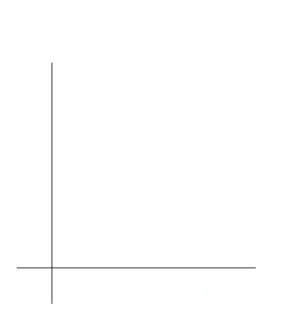
- Based on the p-value, decide whether or not the results are significant and draw your conclusions in context.
  - Indicate whether or not Ho is rejected.

  - Provide a reason for this decision.

  - Draw conclusions based on the results, given the context of the scenario.

  - If Ho is rejected, create a confidence interval appropriate to the given significance level.

