Comparing two means with two independent samples
Math ability of male and female computer science students

Scenario: A study of freshman computer science majors, designed to investigate why students intending to major in computer science failed to do so, collected data on 224 beginning computer science majors in a particular year. The researchers might have been interested in how males and females compared on the SAT Math score (SATM). There is no reason to suspect that either group would perform better than the other. The resulting dataset includes the following variables.
- OBS: ID number
- SATM: SAT Mathematics score
- SATV: SAT Verbal score
- SEX: 1=male; 2=female
Dataset: csdata.por
Data Analysis: Complete the following steps, making notes in response to directions as appropriate:
- State the appropriate null and alternative hypotheses and set the significance level.
Ho:
Ha:
Significance level:

  - Explanatory variable:
  - Response variable:
  - Identify and define the random variable for this test.

  - State what test statistic will be used to summarize the data. Indicate whether a one-tailed or two-tailed test will be used.

- Open the dataset, csdata.por, in SPSS. Check whether the data meet the conditions under which the test can be used. If the conditions are met, summarize the data by a test statistic.
  - Calculate summary statistics and create a histogram (or stemplot) for each of the samples.
  - Confirm that the conditions for use of the chosen test statistic have been met. (Continue even if conditions not met, and be ready to discuss noted violations in follow-up.)

  - Calculate and report the test statistic.

- Find the p-value of the test.
  - p-value:
  - Explain what the p-value means.

  - On a sketch of the normal distribution, label the x axis and shade the region(s) corresponding to the p-value.

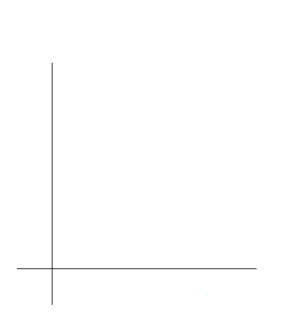
- Based on the p-value, decide whether or not the results are significant and draw your conclusions in context.
  - Indicate whether or not Ho is rejected.

  - Provide a reason for this decision.

  - Draw conclusions based on the results, given the context of the scenario.

  - If Ho is rejected, create a confidence interval appropriate to the given significance level and interpret this interval in the context of the research question.

Based on activity stored at http://wikieducator.org/Comparing_two_means_with_two_independent_samples_--_math_ability_of_male_and_female_CS_students

